SecuGen® USB Fingerprint Reader
User Guide
Installation, Usage, Diagnostic Tools and Troubleshooting

How to install SecuGen Hamster IV device driver In Windows 7

System Requirements for Windows
USB 1.1 port or hub (self-powered for OptiMouse or Keyboard) or USB 2.0 port (Hamster IV)
32MB RAM
20MB available hard disk space
If you are installing an application based on platforms other than Windows, such as Windows CE or Linux, please refer to the documentation provided by the maker of the application program.

Driver Installation Imp Note.

- System should not to be connected with Internet Access.
- Before using your SecuGen fingerprint reader, drivers must be installed.
- Plug in
- Windows starts to find the device driver.

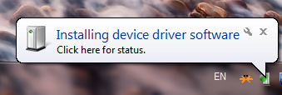

- But you will see the message, “Device driver software was not successfully installed.”

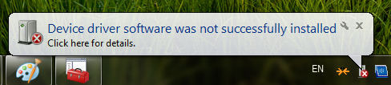

- To install the device driver, the Windows Device Manger will be helpful.
You can run Device Manager in two ways on Windows 7.
- Start -> Control Panel -> Hardware and Sound -> Device Manager in Devices and Printers
- Start-> type in “devmgmt.msc” in Command box.
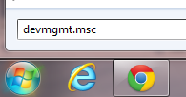

- The Manager shows H20 device as “SecuGen USB U20”.

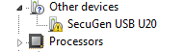

- Right-click on the H20 device and select “Update Driver Software…”

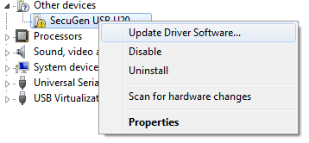

- A dialog box shows up and you choose “Browser my computer for driver software.”
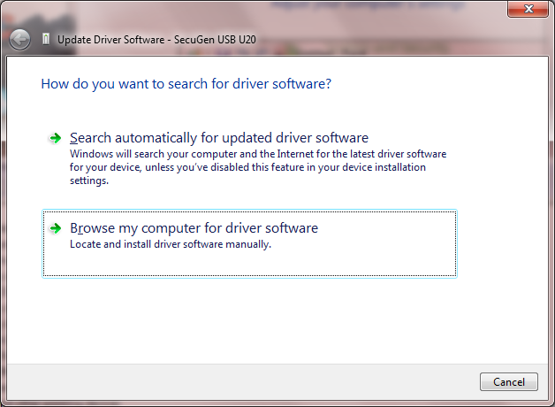

- Locate HU20 device driver. You have to choose the driver for x86 or x64
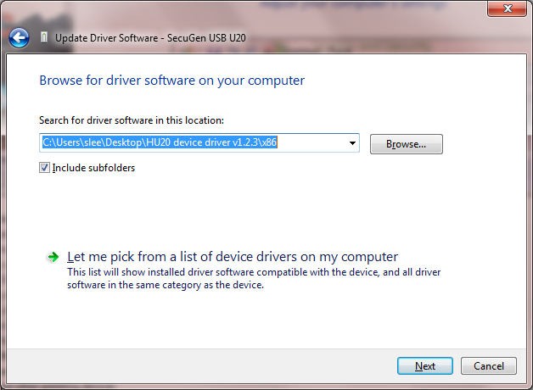
- You should see the message, “… successfully updated your driver…”
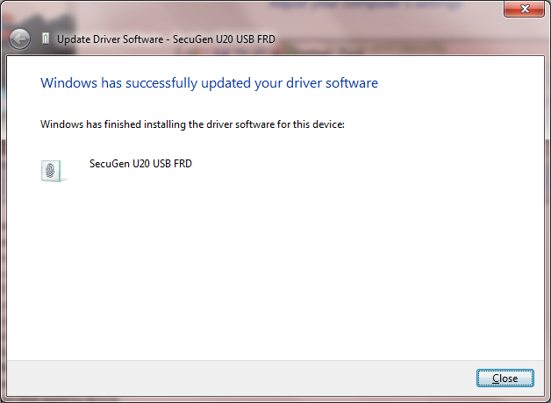

- Now, you can see the right device driver for HU20.
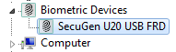

<Properties>
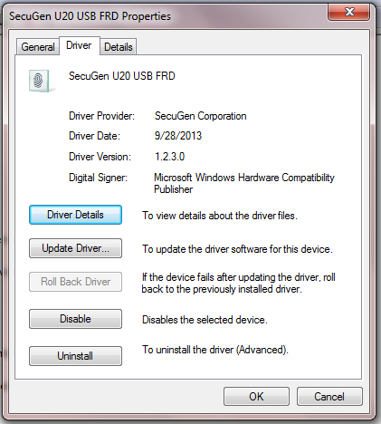

- open Hamster_Pro20_Driver_x86_X64_with_SGDX_Utility extracted folder and run “Sgdx.exe”

- Now click on “init” button and Put your finger on device then click on capture button.
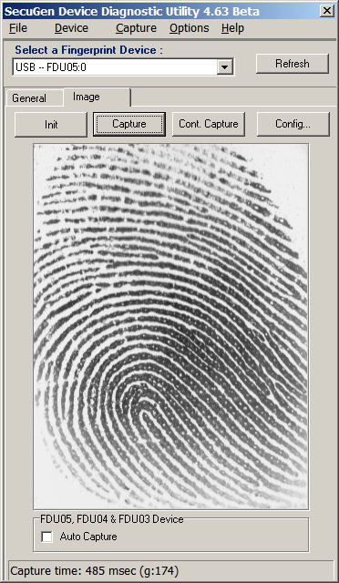
- your finger print image will be shown in this Secugen Diagnostic Utility.
Note: In some case windows will install its default driver and device name should be shown as “Secugen Finger Print Device” in device manager. Secugen Diagnostic Utility (Sgdx.exe) will also work with this default driver.

